
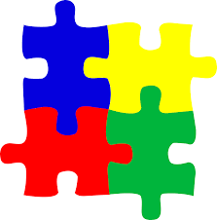

Design Documents

Original Pitch with basic description and tasks . . . . . . . . . . . . . . . . . . . . . . . . . . . . . . . . . . . . . . . 2

Detailed Tasks List . . . . . . . . . . . . . . . . . . . . . . . . . . . . . . . . . . . . . . . . . . . . . . . . . . . . . . . . . . . . 3

Database Tables . . . . . . . . . . . . . . . . . . . . . . . . . . . . . . . . . . . . . . . . . . . . . . . . . . . . . . . . . . . . . . . 4

Context Diagram, Level 0 DFD, and Entity Relationship Diagram . . . . . . . . . . . . . . . . . . . . . . 5

Forms Design . . . . . . . . . . . . . . . . . . . . . . . . . . . . . . . . . . . . . . . . . . . . . . . . . . . . . . . . . . . . . . . . . 7

Objects/Classes : Program structure . . . . . . . . . . . . . . . . . . . . . . . . . . . . . . . . . . . . . . . . . . . . . . . 11
¸.·´¯`·.´¯`·.¸¸.·´¯`·.´¯`·.¸*PuzzPak*¸.·´¯`·.´¯`·.¸¸.·´¯`·´¯`·.¸

Description:
This application would contain 2 or more form games that a user could play in order to obtain a score. After playing the game and getting a score, the user has the option to post their score using a username they create on-spot. The form games themselves know the score for the current game, as well as the user's accuracy with making the correct moves in a puzzle.

After the user plays the games, they have the option to check the Leaderboards back at the main menu. This leaderboard is connected to a scores Database, which shows a player's name, score, and accuracy. The leaderboard is split into groups: Hangman scoreboard, MemoryGame Scoreboard, and overall Scoreboard. Each of those groups has these subgroups: All-time High score, Today's highest scorers, Highest scorers this Month, This Year's top Scorers.

Tasks:
*Play a selected form-based game, and get a score upon completing it to the best of their ability.
*Post their score under a username. (this is not a log-in based account.)
*Scores will be listed in the Highscores database from highest score to lowest, with username next to it.
*Determines which users are in the top-10 for each form game, and in the All Time top scores for all games.
*Determines who is the top scorer for the day, each month, and each year.
*Determines consistent top-10 users (in daily, monthly, and yearly scoreboards, for specific game, and all-time).

¸.·´¯`·.´¯`·.¸¸.·´¯`·.´¯`·.¸*PuzzPak*¸.·´¯`·.´¯`·.¸¸.·´¯`·´¯`·.¸
Tasks

PLAYING & POSTING YOUR SCORE
*Launches games that come in the Game Pack.
*You may “sign in” using a continue-as... button so that every score you get from games in the pack don't have to keep asking you for your score.
-Post your score From within Game form To the database.
-xGame Top-10 scores
-xGame All-Time scores
-After posting:
-Leaderboard available to let user then see where they are on the Daily scoring, and list 5 people above them, and below them.

LOOKING THROUGH THE SCOREBOARD
*Main menu form database access. Accessing the score Database (for whichever table) will generate a report that shows username,rank, score, and Game.
*everytime the “leaderboards” button is pressed, it re-queries the database and reloads all tables in the form. They're ordered by descending Score.

-Access Hangman Table
-Access Hangman All-time scores (which just means all scores ever recorded for this game.)
-Determine Hangman Top-10

-Access MemoryGame Table
-Access MemoryGame 4x4 All-time scores
-Determine MemoryGame 4x4 Top-10
-Access MemoryGame 6x6 All-time scores
-Determine MemoryGame 6x6 Top-10

-Access Tik-Tak Table
-Access MemoryGame 4x4 All-time scores
-Determine MemoryGame 4x4 Top-10

-Players Table
-Lists a player and their highest score in each game.
-will be ordered by who has the highest percentage of higher scores, to highlight the best players and their top scores, as well as save scores to an individual person/account.
¸.·´¯`·.´¯`·.¸¸.·´¯`·.´¯`·.¸*PuzzPak*¸.·´¯`·.´¯`·.¸¸.·´¯`·´¯`·.¸
Tables

HANGMAN TABLE tik-tak table

MEMORYGAME TABLES

The Top-10 Tables that show up in
the leaderboards form will be queried
from these All-Time tables, and there
is no use for a dedicated table in the
database for them.

Results in the Top-10 table are ever-
changing and depend on the data in the All-Time Table.
To fill it, it would query the top 10
scorersin All-Time and put them in
order. If there are 2 tuples with the
same score, it will be further ordered
by date, and if they're on the same
date, further ordered by their Post
Number.

Player Table
To Query All-Time to result in
Top-10 results:
SELECT *
FROM hangmanAllTime
ORDER BY score DESC, ORDER BY date DESC,postNo
LIMIT 10;

¸.·´¯`·.´¯`·.¸¸.·´¯`·.´¯`·.¸*PuzzPak*¸.·´¯`·.´¯`·.¸¸.·´¯`·´¯`·.¸
Diagrams

DATA FLOW DIAGRAM – Context Diagram

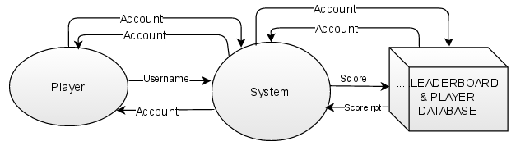

Data Flow Diagram – Level 0

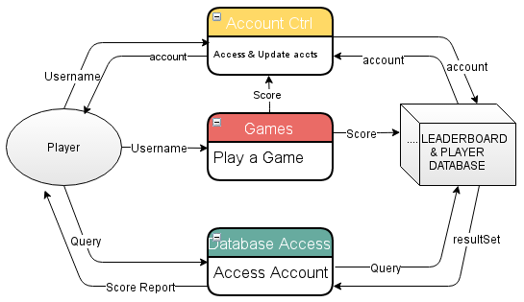

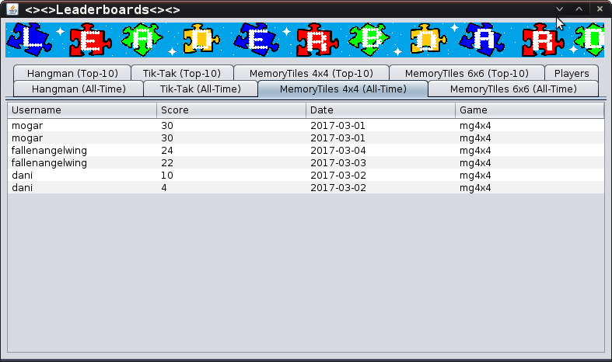
ENTITY RELATIONSHIP DIAGRAM
¸.·´¯`·.´¯`·.¸¸.·´¯`·.´¯`·.¸*PuzzPak*¸.·´¯`·.´¯`·.¸¸.·´¯`·´¯`·.¸
Forms

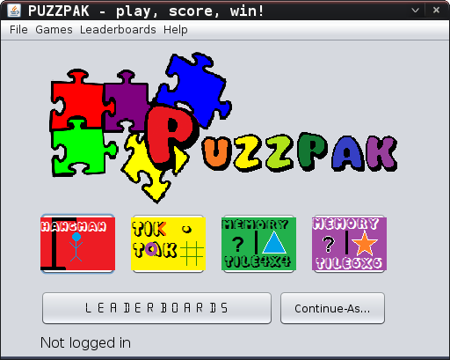
Main Menu

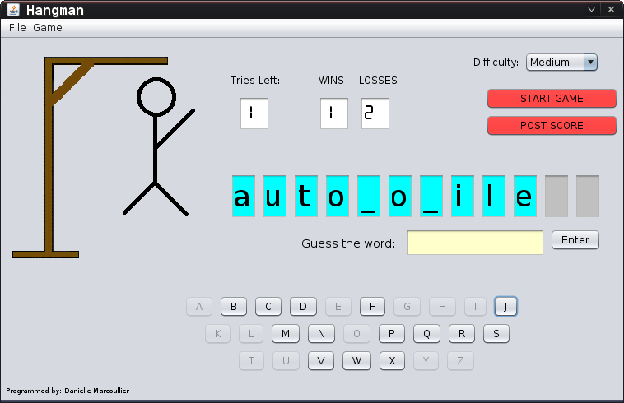
Hangman

MemoryGame 6x6
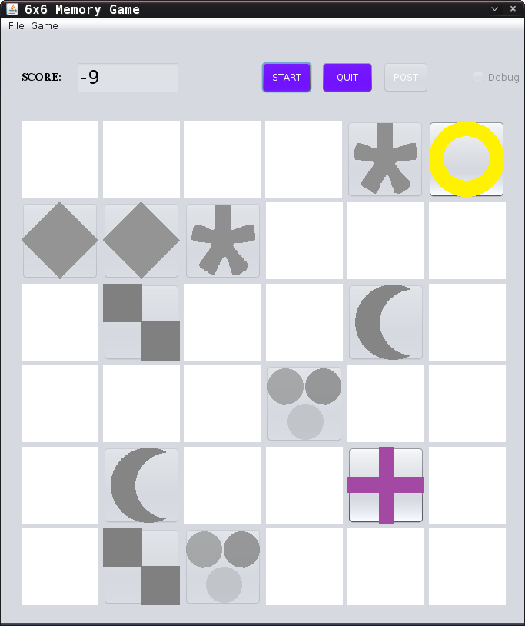

MemoryGame 4x4
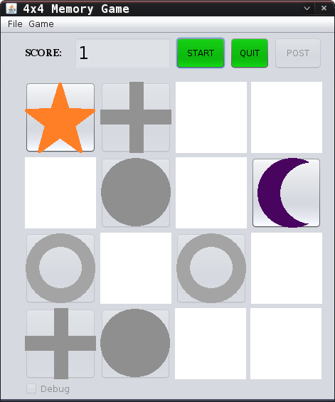

Tik-Tak
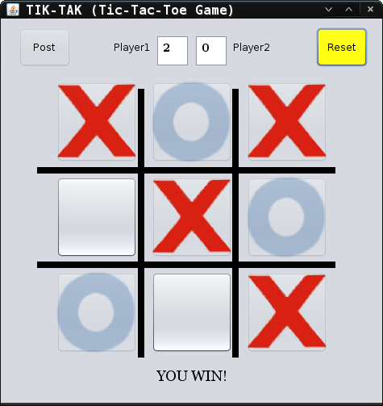

Leaderboards
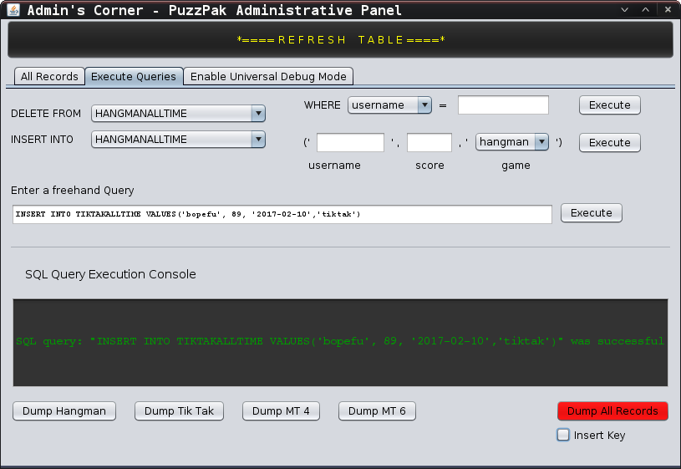
Admin's Corner – administrative panel
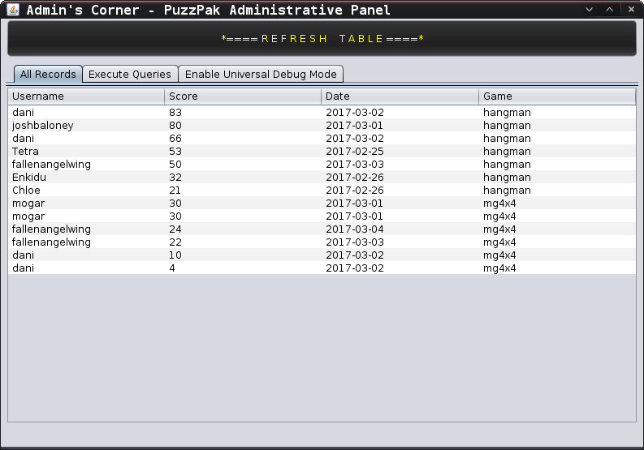
¸.·´¯`·.´¯`·.¸¸.·´¯`·.´¯`·.¸*PuzzPak*¸.·´¯`·.´¯`·.¸¸.·´¯`·´¯`·.¸
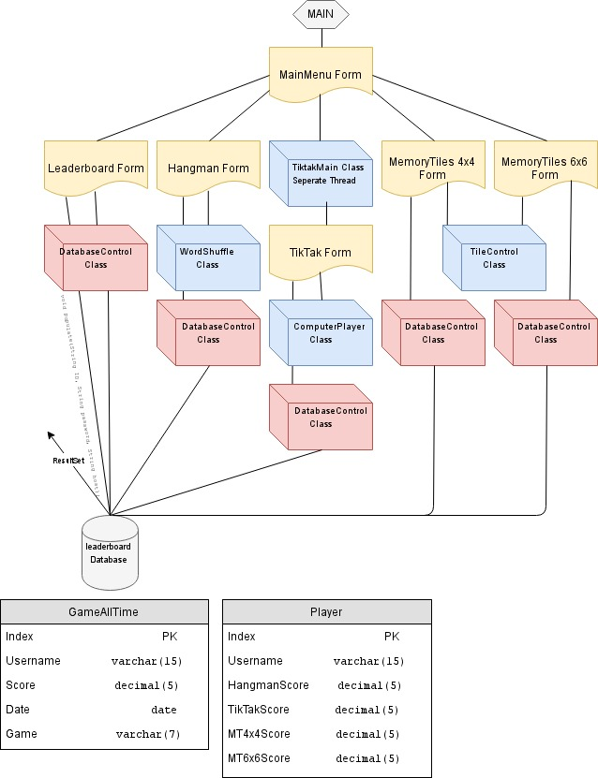
Objects

